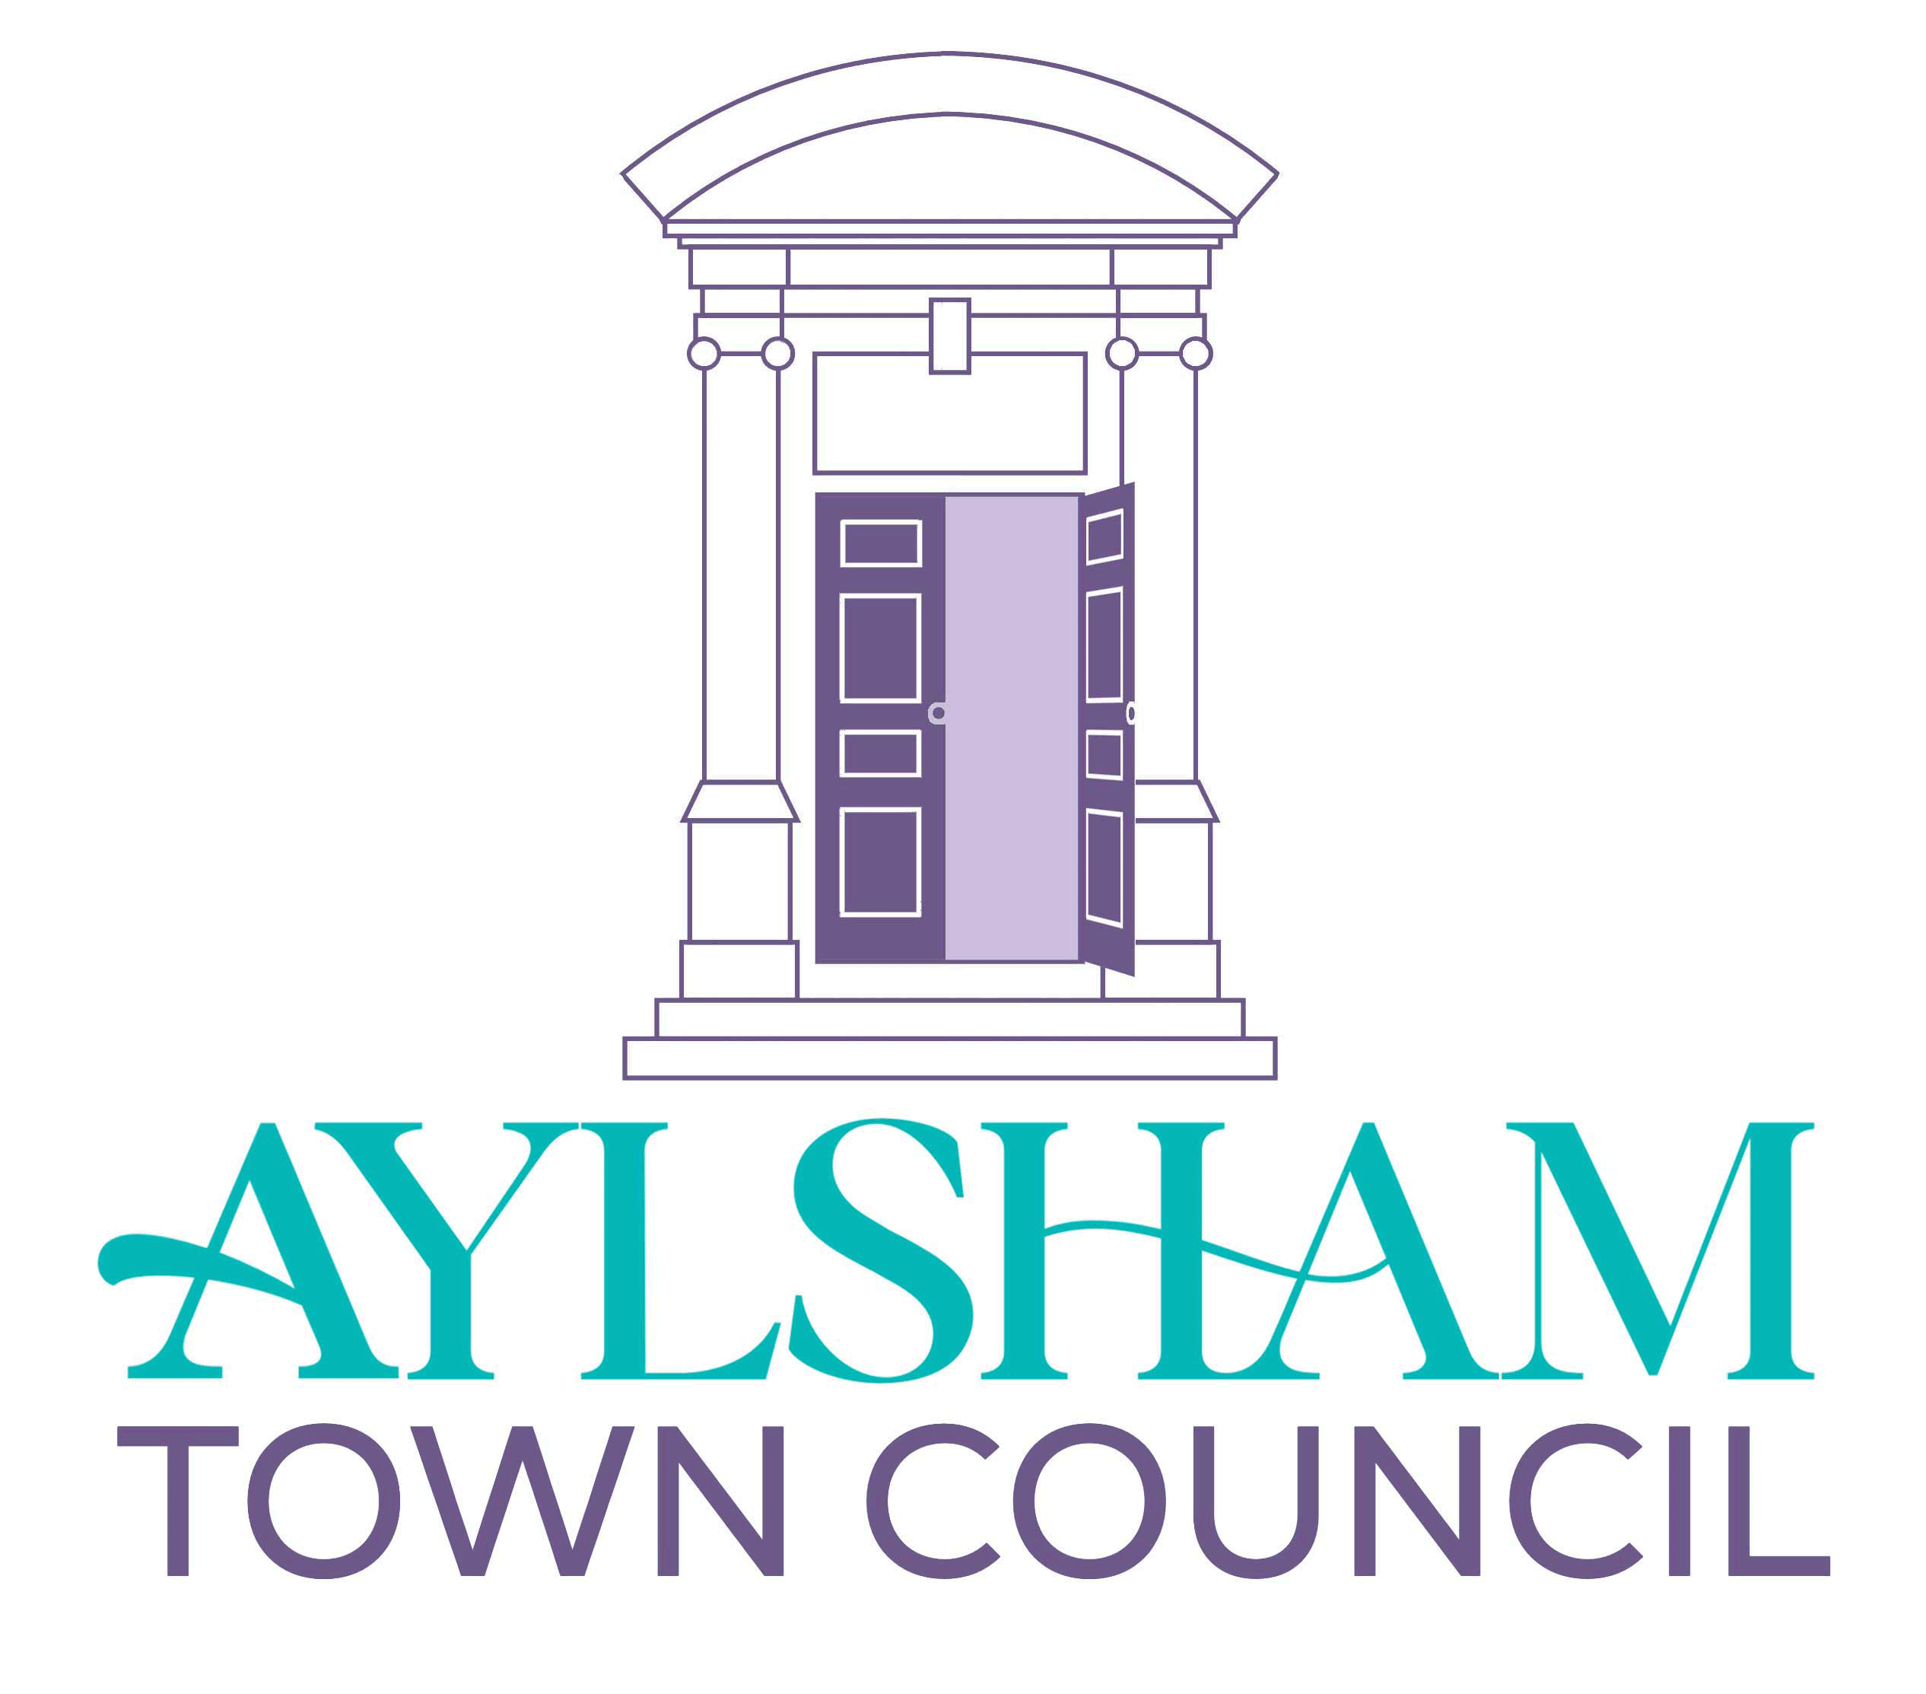 | AYLSHAM TOWN COUNCIL
Council Office, Town Hall, Market Place, Aylsham, Norwich, Norfolk NR11 6EL.
Tel.. – 01263 733354 (09:30 to 3:30)
email – townclerk@aylsham-tc.gov.uk
Website – www.aylsham-tc.gov.uk
PERSON SPECIFICATION – Grounds Staff (part time 25 hours per week)

Essential

- Full driving license.

- A flexible approach to working such hours as are necessary to meet the demands of the service. Weekend working may be necessary

- A willingness to undertake further training

Desirable

- PA1 and PA6 spraying licence

- Introductory level chainsaw operative qualification

- Previous experience of basic DIY task

- Previous experience of operating grounds maintenance machinery

- Previous experience of working in a grounds maintenance environment

- Previous experience of horticulture

- A basic horticultural knowledge

- A basic knowledge of fine turf maintenance

- A basic knowledge of grounds maintenance machinery and maintenance requirements

- A knowledge of mechanical operation of grounds maintenance machinery

- Ability to operate a variety of grounds maintenance machinery

