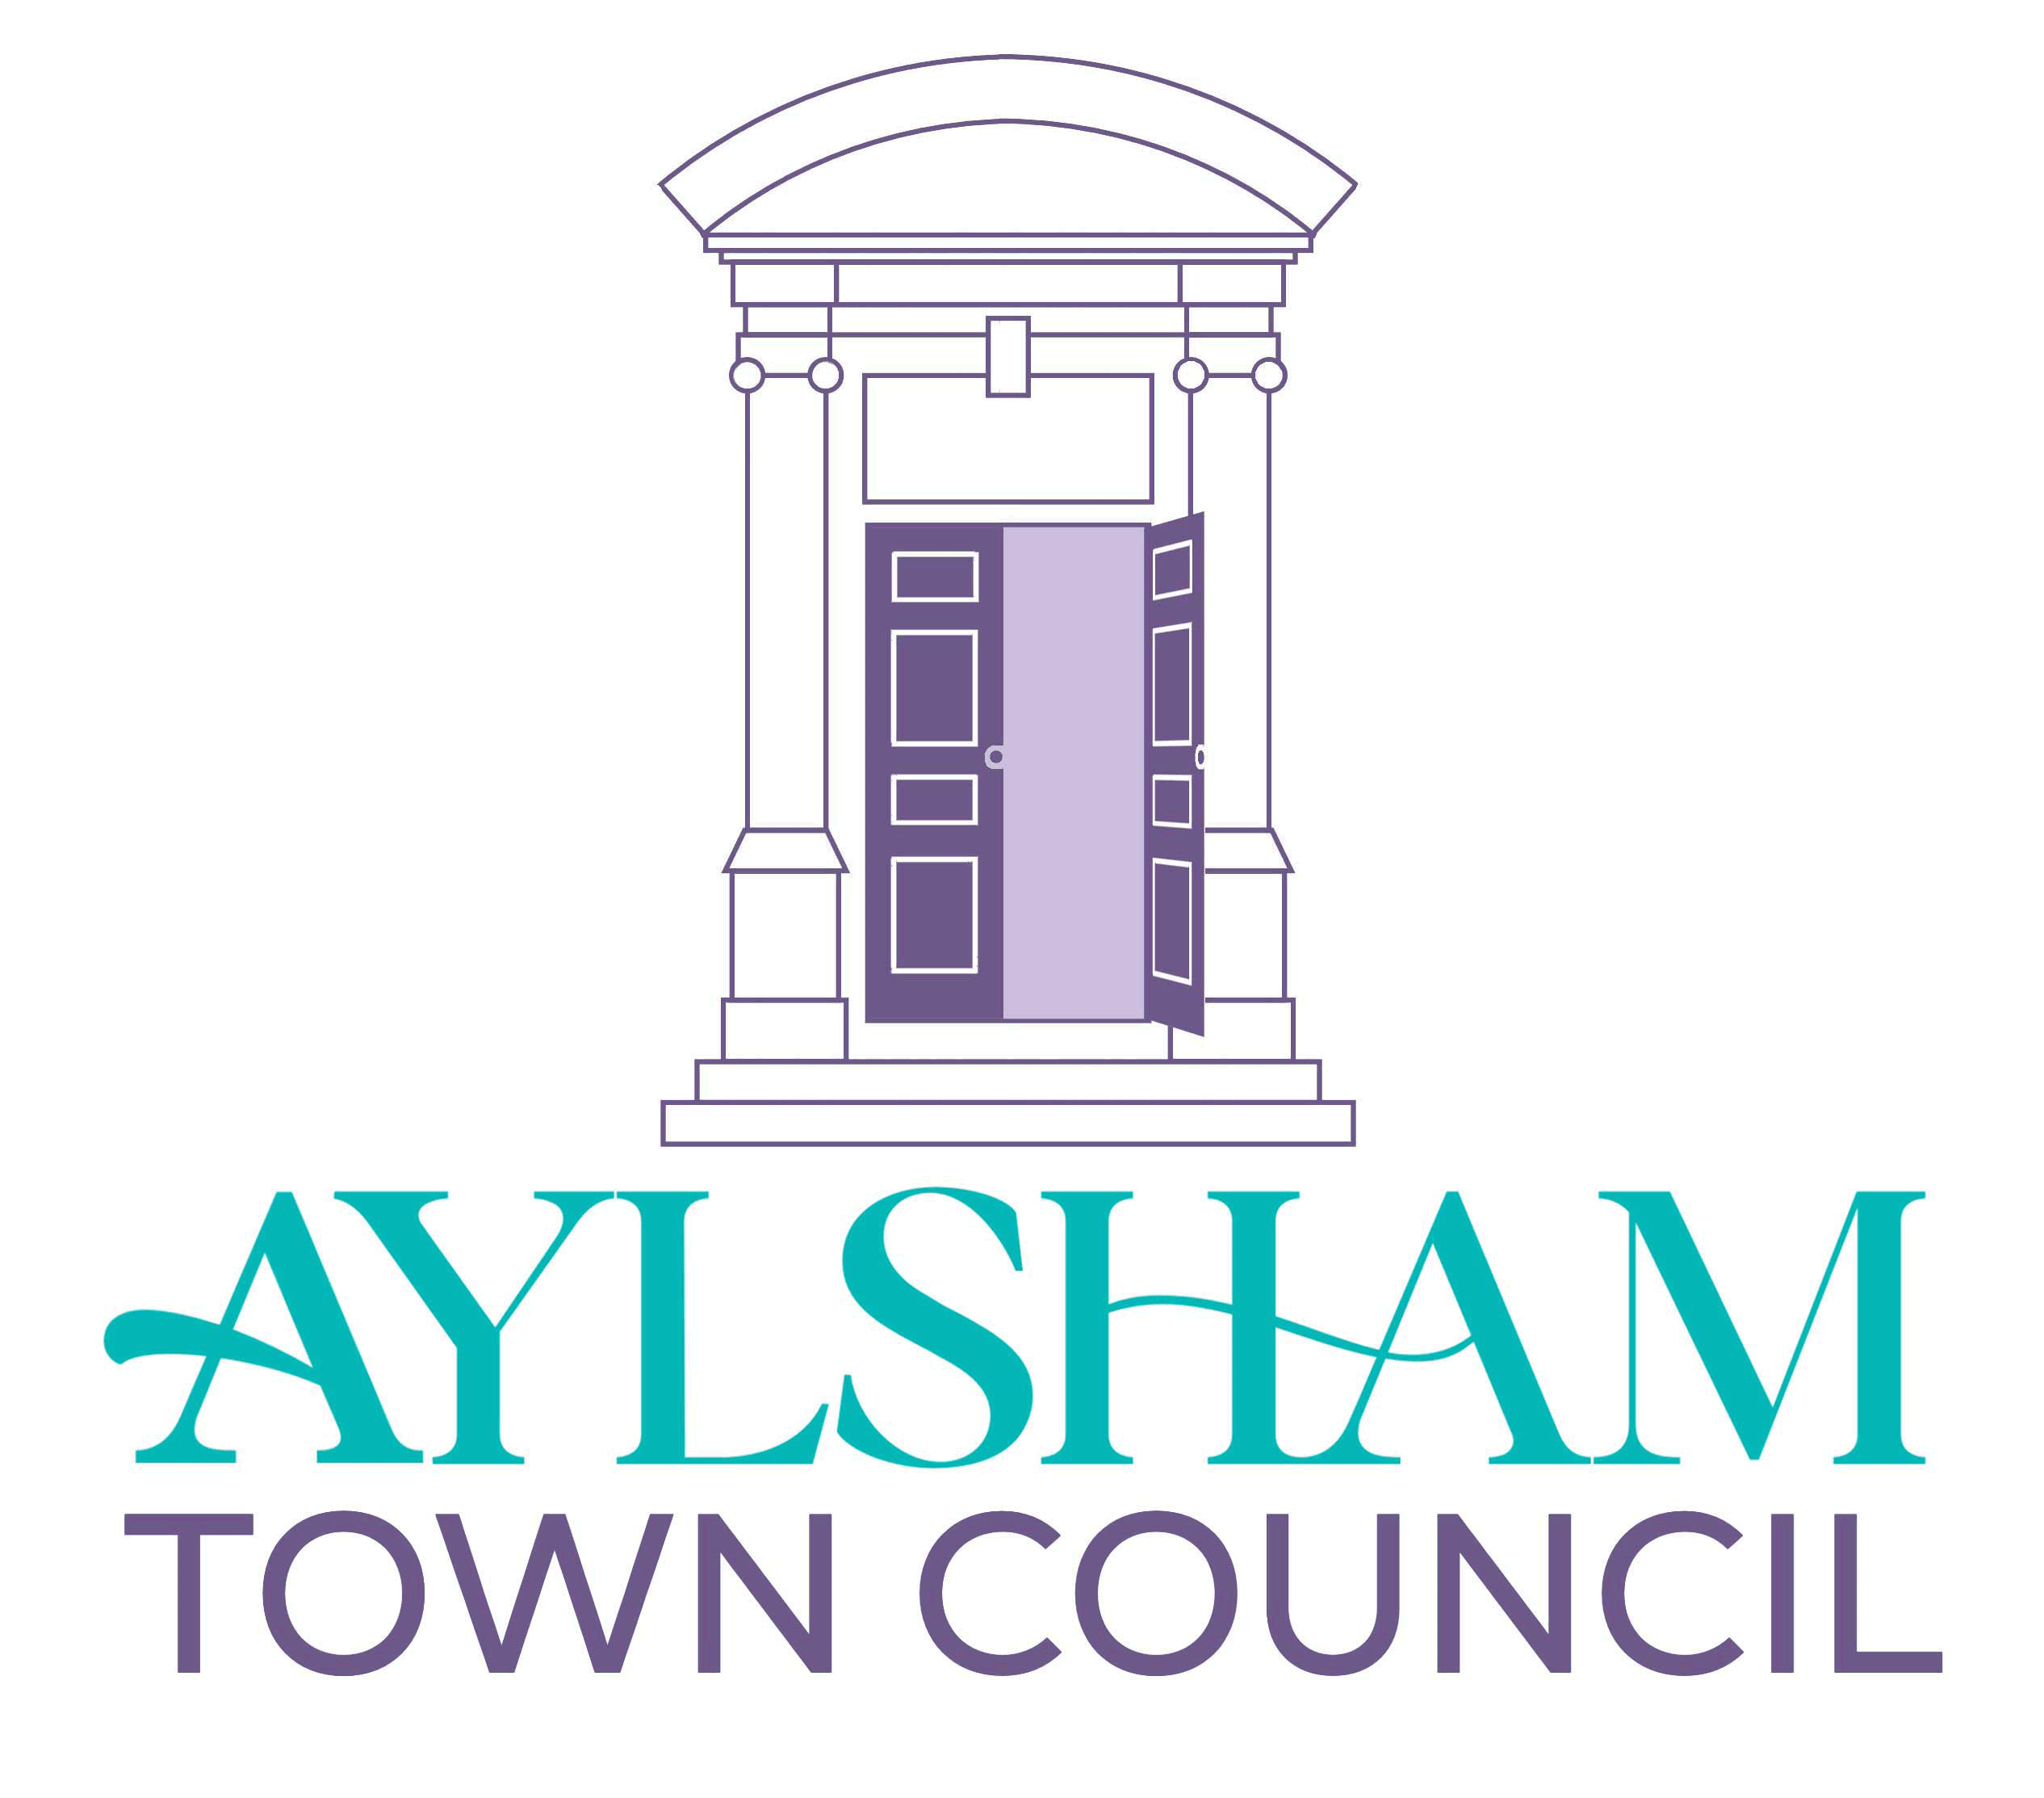 | AYLSHAM TOWN COUNCIL
Council Office, Town Hall, Market Place, Aylsham, Norwich, Norfolk NR11 6EL.
Tel.. – 01263 733354 (09:30 to 3:30)
email – townclerk@aylsham-tc.gov.uk
Website – www.aylsham-tc.gov.uk
JOB DESCRIPTION – Grounds Staff (part time 25 per week)

Main purpose of job: To manage the grass cutting, hedge cutting and other gardening activities of land owned or managed by the Town Council .
__________________________________________________________________

MAIN DUTIES

- To carry out a wide variety of grounds maintenance tasks and operations on a day-to-day basis across all sites owned, managed or maintained by Aylsham Town Council

- Operation and initial maintenance of grass cutting machinery including ride on mowers, brush cutters, rotary and cylinder mowers and other machinery that from time to time the Council may be in possession of

- Collection of litter and refuse from Council sites when cutting

- Tree and shrub maintenance using hand tools and motorised machinery (including chainsaws)*^{subject to qualifications}

- Maintenance of flower and shrub beds

- Clearance of allotment plots

- Minor DIY operations across all Council sites

- Basic health and safety inspections of Council assets

- Undertake training in the handling storage of chemicals (COSHH), health and safety, handling of equipment and any other training as required

- Stewarding and manual support for Council events.

- Any other associated duties as required from time to time by the Town Clerk or Maintenance Manager.

