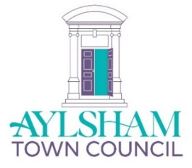
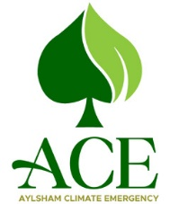
AYLSHAM TOWN COUNCIL
ACE PROJECT PROPOSAL

Approved in Principle:

Full Approval:

PROJECT TITLE:

ACE SUB-GROUP(S) INVOLVED:

LEADER OF PROJECT:

OUTLINE of the PROJECT
Please write a brief description of the project, including full details of how the project will be delivered and any working partnerships involved.

Timescale:

External Funding (please specify):

Approximate funding required from ACE/Town Parish Council £….……….

ABOUT the PROJECT
What is the need for this Project?

Who will benefit?

How will those taking part help design, implement & evaluate the project?

How many will be involved, and how they will contribute to the Project.

Is Town Council staff involvement required?

If so, what will this entail?

What are the publicity requirements and who will lead on this?

How will progress on the project be reported back to ACE?

How will the success of the project be evaluated?

WHEN WILL THE PROJECT BEGIN & END?
Estimate if unsure:

START: END:
Month & Year: Month & Year:

Procedure for ACE Projects

In the first instance, members are required to complete this Project Form, giving an outline of what the project involves and an approximate cost. This will be considered by ACE, and if it is supported, it will receive approval ‘in principle’, and will be able to progress to the next stage.

Members are then required to provide more details of the project, including plans, maps, drawings and work programmes.

The full proposal will be considered at an ACE Meeting and if necessary the following Town Council Meeting. If the project gains full approval, it will be managed by the relevant sub-group with regular reports to ACE.

Please complete this form and send to the Town Clerk (townclerk@aylsham-tc.gov.uk) at least one week prior to the ACE meeting at which it will be considered.

Submitted by…………………………………………….

Date…………………………………………

